BALDWIN CEMETERY
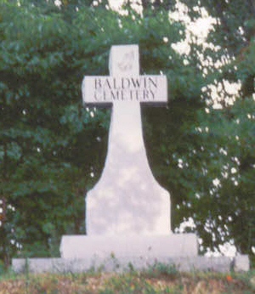
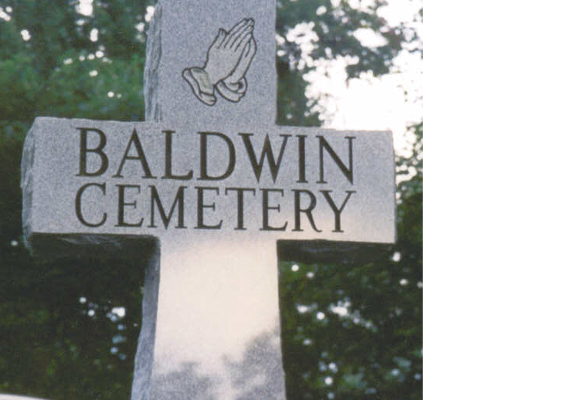
Drill, Virginia

Baldwin Cemetery is located on Stinson Ridge in the Drill section of Russell/Buchanan County. On Drill Road, route 624, turn onto route 622. Approximately one mile up the mountain, take a right onto route 625. The Baldwin Cemetery is on the top of the mountain on the right.

This file contributed by Jeanine Harris: Jeanine.Harris@HCAHealthcare.com

Solomon Baldwin
August 7, 1861 – December 19, 1947

Rosan Lowe Baldwin (wife of Solomon Baldwin)
1855 – March 20, 1938

Asa C. Baldwin (son of Solomon)
April 8, 1888 – March 9, 1960

Lillie Fletcher Baldwin (wife of Asa Baldwin)
September 29, 1885 – October 25, 1950

Nannie E. Helton Baldwin (second wife of Asa Baldwin)
May 13, 1896 – Buried in Helton Cemetary

Paul Baldwin (son of Asa Baldwin)
February 28, 1909 – June 7, 1972

Earl Baldwin (son of Paul Baldwin)
March 21, 1948 – May 7, 1956

Dewey J Baldwin Geneva Baldwin (w/o Dewey; d/o of Bob & Romia Blankenship)
January 1, 1919 – October 19, 2000 September 19, 1943 – August 20, 2003
(s/o Asa Baldwin & Lilly Fletcher)

James Baldwin (son of Dewey Baldwin)
September 8, 1950 – September 8, 1950

Betty Baldwin (daughter of Dewey Baldwin)
January 17, 1963 – April 26, 1963

Billy Baldwin (son of Dewey Baldwin)
February 24, 1966 – February 24, 1966

Dallas Baldwin (son of Dewey Baldwin)
November 17, 1970 – living
Callie Lou Hess (daughter of Geneva Baldwin)
June 21, 1974 – living

Joyce Ann Blankenship
November, 12 1949 – February 1, 2005
(w/o 1st. Benny L. Blankenship, 2nd. Lucas Blankenship)
(d/o Dewey Baldwin & Eula Bea Lowe)

Raymond Baldwin (son of Asa Baldwin)
June 21, 1923 – November 14, 1949

Lola Sheppard (daughter of Asa Baldwin)
1907 – 1952

McKenley Sheppard (husband of Lola Baldwin Sheppard)
November 14, 1895 – January 28, 1956

Lonie Baldwin (daughter of Asa Baldwin)
February 25, 1912 – February 25, 1912

Harles Rasnake (daughter of Asa Baldwin)
1919 – 1985

Billy Dean Owens (grandson of Asa Baldwin, son of Vern Baldwin Owens)
October 19, 1961 – January 30, 1982

Henry W. Baldwin (son of Solomon Baldwin) Catherine Ball Baldwin (wife of Henry Baldwin)
October 4, 1882 – March 19, 1949 January 1, 1894 – June 20, 1979

Thomas W. Mitchell (husband of Ruby) Ruby M Mitchell (daughter of Henry Baldwin)
December 19, 1919 – December 8, 1991 April 1, 1920 – living

Philis Wampler (daughter of Ruby Mitchell) Carols Eugene Wampler (husband of Philis)
February 3, 1945 – living December 4, 1938 – March 26, 1973

Mildred Breeding (daughter of Ruby Mitchell) Donald Breeding (husband of Mildred Breeding)
November 4, 1946 – living May 7, 1944 – June 7, 1966

Donna Sue Mitchell (daughter of Ruby Mitchell)
April 12, 1948 – January 22, 1963

Virginia B. Mitchell (daughter of Asa Baldwin) Cecil Mitchell (husband of Virginia Mitchell)
January 9, 1928 – living March 12, 1922 – November 25, 1976

Donna Tenise Mitchell (granddaughter of Virginia Mitchell)
March 13, 1971 – March 27, 1971

Barbara June Mitchell Israel Larry W. Israel (husband of Barbara, s/o Goldie Israel)
December 1, 1950 – August 27, 1997 January 16, 1950 – living
(w/o Larry W. Isreal, d/o Thomas W. Mitchell & Ruby Baldwin)

Krista L. Snead (great-granddaughter of Ruby Mitchell)
December 19, 1978 – December 20, 1978

Mary F. Hess (daughter of Solomon Baldwin)
January 26, 1881 – May 12, 1967

James H. Hess (husband of Mary Hess)
March 4, 1886 – April 29, 1985

J. Harvey Stevens (h/o Monnie) Monnie L. Cook(d/o Mary Hess) Walter R. Cook (2nd h/o Monnie)
1900 – 1930 1907 – 1989 1910 – 1972

Roger Cook (son of Monnie Cook) Barbara Cook (daughter of Monnie Cook)
1941 – 1942 1943 – 1943

Lacy Edith Stevens Mabe (daughter of Monnie Cook)
September 5, 1926 – December 14, 1998

Virginia Stevens Johnson (d/o Monnie Cook) Ervin Johnson (husband of Virginia Johnson)
1930 – 2002 1930 – living

Corbet Ballard Cook (son of Monnie Cook) Billie J. Cook (wife of Corbet Ballard Cook)
1936 – 1998 1946 – living

Hersel Smith (2nd h/o Helen Ruth) Helen R. Cook (d/o Monnie Cook) Calab G. Elswick (h/o Helen Ruth)
3/2/1932 – 8/6/1981 12/30/1935 – living 7/10/1895 – 11/14/1964

Anna Leah and Anthony Levi Mabe (twin grandchildren of Lacy Edith Mabe)
6/20/1970 – 6/20/1970

Sada B. Hess (daughter of Mary Hess)
September 4, 1910 – December 16, 1910

Robert Lee Hess (son of Mary Hess)
September 16, 1911 – June 30, 1934

Gracie Hess Colston (daughter of Mary Hess)
1917 – 1972

Preston Howard Hess (son of Mary Hess)
October 22, 1919 – June 23, 1966

Hattie A. Blankenship (daughter of Mary Hess) Casey J. Blankenship (h/o Hattie, s/o Kansas)
March 2, 1914 – February 25, 1997 June 22, 1909 – January 17, 1981

James Larkin Blankenship (son of Hattie & Casey Blankenship)
March 17, 1944 – March 17, 1944

Peggy L. Martin (d/o Hattie & Casey Blankenship) Clarence L. Martin (husband of Peggy)
4/19/1936 – 8/26/2002 5/31/1916 – 9/6/1983

Megan Hope Brown (granddaughter of Peggy Martin)
8/20/1988 – 8/20/1988

Callie Kansas Blankenship (d/o Solomon Baldwin) Charlie Thomas Blankenship (h/o Kansas)
1886 – 1974 1881 – 1933

Noria Ann Blankenship (daughter of Kansas Blankenship)
1908 – 1919

Parker Cox Blankenship (son of Kansas Blankenship)
1919 – 1919

Oakley Bell Peck (d/o Kansas Blankenship) Verney Omar Peck (husband of Oakley)
3/5/1914 – 12/24/1979 8/29/1915 – 3/16/1970

Hershell Lee Jackson (grandson of Kansas Blankenship)
January 15, 1946 – December 29, 1948

Robert “Bob” Blankenship (son of Kansas Blankenship) Romia Blankenship (w/o Bob, d/o Mary Hess)
October 12, 1911 – January 7, 1996 July 1, 1921 – living

Lorine Blankenship (daughter of Bob & Romia Blankenship)
9/5/1942 – 9/12/1942

Benny L. Blankenship (son of Bob & Romia Blankenship)
7/18/1950 – 9/27/1971

Johnny E. Clayburne (grandson-in-law of Bob & Romia)
1948 – 2003

Ida B. Hess (daughter of Solomon Baldwin) Richard L. Hess (husband of Ida Hess)
1884 – 1972 1884 – 1965

Bertha Hess (daughter of Ida & Richard Hess)
2/24/1903 – 1/14/1908 *FIRST GRAVE

Baby Violet Hess (granddaughter of Ida Hess)
October 30, 1930 – October 30, 1930

Baby Amos (grandson of Ida Hess)
December 24, 1942 – December 24, 1942

Goldie Israel (daughter of Ida Hess) Walter Israel (husband of Goldie Israel)
September 22, 1910 – February 4, 2001 March 31, 1895 – November 16, 1986

Leslie T. Israel (son of Goldie Israel) Lois Ann Israel (wife of Leslie Israel)
February 1934 – living May 5, 1949 – October 31, 2002

Bobby Israel (son of Goldie Israel) Alice Israel (wife of Bobby Israel)
March 19, 1943 – April 30, 2000 April 19, 1946 – living

Dixie S. Smith (daughter of Ida Hess) Carson Smith (husband of Dixie)
1915 – 6/30/1999 1913 – 1974

Curtis Smith (son of Dixie Smith) Kathleen Taylor Smith (wife of Curtis)
1939 – 1986 1937 – living

Kirby Allen (Johnny) Smith (son of Dixie Smith) Ann Smith (wife of Johnny Smith)
1940 – 1997 living

Eula Gay Smith (daughter of Dixie Smith)
6/27/1943 – 1/8/1944

Curtis Anthony Smith (grandson of Dixie Smith, son of C.A. Smith)
1/2/1983 – 1/2/1983

Bill & Alice Shelton (sister of Rosan Baldwin) – unmarked tombstone

Bert E. Martin (husband of Ida Cook Martin)
November 21, 1902 – May 1, 1974

Ida Cook Martin (wife of Bert E. Martin)
August 19, 1914 – March 7, 1968

Mary Martin (daughter of Bert & Ida Martin)
living

Maude Owens
1888 – 1961

Josephine O. Jones (daughter of Maude Owens)
1918 – 1961

George W. Lang
1898 – 1988

Wallace Miller Lang
5/19/1926 – 7/4/1992

Maudine R. Ball Meade (w/o Bryant Wood Meade,Jr., stepdaughter of Paul Baldwin)
12/31/1938 – 10/21/1998

Bryant Wood Meade Jr. (h/o Maudine Meade, s/o Bryant Wood Meade,Sr. & Maggie Lou Harrington)
1933 – 2000

Pamela McCarty 1985 – 2003 One
Elysia Underwood 2002 – 2003 grave
Arnold Ball (brother of Catherine Baldwin)
1925 – 2003

Garnet Ellis Ball (brother of Catherine Baldwin)
1934 – 1997

Rosa Ball (sister of Catherine Baldwin)
6/22/1889 – 3/21/1987

Vergie B. Terry
9/4/1918 – 5/17/1993

Estil Terry (husband of Vergie Terry)
7/2/1909 – 7/21/1996

Baby Maxfield (great-grandson of Vergie Terry)
1985 – 1985

Three unknown graves marked with field rocks

Total 113 markers, 101 buried

